## 

## Merchant

Demo date: Nov 7, 2024  
Scoping start date: Sep 16, 2024

MSA Signature Date: Nov 13, 2024  
Onboarding Kick Off Date: Nov 18, 2024

[If Exists] Opt Out Date: Oct  
Go Live Date: Jan 1, 2025

GTM POC: Ben  
Implementation POC: Jeff

ERP: QBOeate

Tax Integration: No Tax - most customers are school districts so they are tax exempt

Customer volume: 250 customers

Billing model: Annual up front

### 

### Key people at Merchant

### Director of Finance: Diego

### CEO: Mike (focused more on the sales ops side) - Sales side

### 

### 

| Notes Sections [Ops International Team to Ignore] *(AE/ Implementation to fill)*   * Info on how merchant bills   + Annual up front (typically)   + Fall under school district cycle   + Complexities     1. Parent & Child relationship billing     2. E.g., BOC - one of the more gnarly ones (Bill vs. Ship to Address) * Is there any important merchant relationship information?  1) What is the merchant's temperament?   Diego is awesome and going to be an excellent partner for us 2) Is there a key POC: (i.e.: who is the buyer/decision maker?)  Diego is the key POC, he will be the main user of the platform  Mike cares that Diego is happy and able to do everything he needs to  3) What are the Tabs features that the key POC cares about?  Better management of their contracts and ability to support a more complex enterprise use case |
| --- |

### 

### Company summary *(AE to fill)*

Droplet.io provides a platform designed to help businesses create digital forms and streamline workflows, particularly targeting organizations that want to transition from manual or paper-based processes to automated, digital systems. They largely target the public sector.

Their platform supports a range of needs, including data collection, task automation, and digital approvals, with custom forms and secure storage. Droplet charges customers for access to these tools, through a subscription model

Goals (North star)  
*(AE/ Implementation to fill)*

What is the merchant's goal? What pain are we solving? Why are they buying Tabs?

Main reason they are buying now is their current tool, Cacheflow, does not handle robust enterprise contracting well - Tabs will better support their contract complexity needs

Cacheflow was just acquired by Hubspot. They are SFDC users and support for them is going to the wayside.

* MSAs vary wildly, which cacheflow has challenges handling
* They do a ton of redlining with their customers - when those changes happen they stall the process in cashflow (which is made for SMB vs a publicly funded buyer that has way crazier needs)
* Sales team does not like how rigid cashflow can be, would love to use the quoting tool

Is there an opt out clause? If so, what is the merchant looking for so they do not exercise it?  
No Opt out, 2 year contract

### Billing model *(AE/ Implementation to fill)*

* Are there unique things about the customer creation process for this merchant?

Each customer has different rulesets and conditions - 85% or more times they come back with redlines and have to fold to do business

Most frequently their jurisdiction gets redlined - IE in the case of arbitration, the opening case opens in that place

* Information on how merchant bills

Mostly flat SaaS fee, but occasionally have a usage component

* How contract is broken up
* One off things to know about the merchant

They have a handful of customers that have parent child relationship needs. Their 2 BOCES customers are the main ones to flag.

Tax - most customers are school districts so they are tax exempt

### Contract Processing Steps *(Implementation/Success to fill)*

1. Steps to process
   1. **Guidance on Customer name:** Customer should already exist in Tabs, these have been synced from QBO and will be in contract name
      1. Should not need to use sub-customer
      2. Refer to *effective date* to populate *Service start date* in Revenue Schedule
      3. *Total months of service* and *# periods* = 60
      4. **Bolded** line item under *Dates* is used for both *Item name* and *Integration item* in Garage

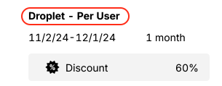

* + 1. Use *Total* *Price* and *Quantity* from each individual line item in contract
       1. Do not use Unit Price, as there are instances where quantity > 1

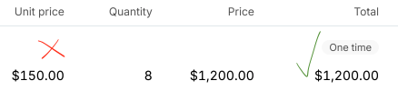

* + 1. Net terms found immediately under **Payment schedule** in contract
  1. **If the contract only shows one year** *(see an example for Brunswick County Board of Education below) Refer to this* [*garage link*](https://garage.tabsplatform.com/prod/contracts/09724795-8018-4668-8312-726c566a1e3a/terms/revenue) *to see an example of processing*
     1. Steps mirror those outlined above
     2. Note this contract is not on auto-renew, so period = 1
  2. **If the contract includes Professional Services** *(see an example for Silver Creek Mortuary below) Refer to this* [*garage link*](https://garage.tabsplatform.com/prod/contracts/f83273de-6d8f-43c4-bc80-6cc9708cc173/terms/revenue) *to see an example of processing*
     1. Steps mirror those outlined above
     2. Frequency = None in Garage for Pro Serv line items
        1. These do not expire and are not tied to a specific period

1. Anything to ignore in contracts?
   1. Do not display discount percentage or discount amount unless it is explicitly called out as its own line item
   2. Do not include bulleted descriptions of line items anywhere on invoice
   3. Do not include *Transaction Processing Fees* - these are handled in Billing Settings
2. Specifics processing things the merchant has requested that may differ by contract (e.g. always back-date invoice date to final day of the month)
   1. Contract length and payment terms will differ by contract
   2. If stated in contract, include *PO #* in Key Terms

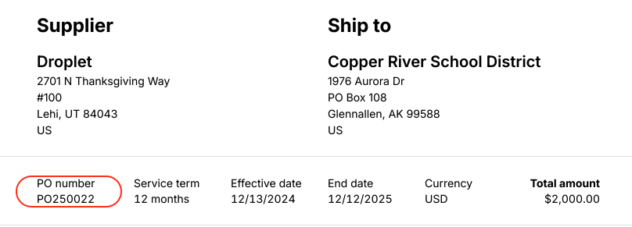

1. Default Service Term
   1. Refer to contract
2. Default Net Payment Terms
   1. Refer to contract
   2. Will be displayed under *Payment schedule*
3. Default Billing Frequency
   1. Refer to contract
4. How do we handle taxes as a line item?
   1. No taxes
5. PO Uploads
   1. If a PO is uploaded and there is an associated MSA with that customer, input the PO number on the originally generated invoices and mark the PO as processed with no BTs
   2. If not MSA on the customer for whom the PO was uploaded, please process the PO as a contract and generate invoices

### Events Processing (if necessary) *(Implementation/Success to fill)*

* Any important information on events billing

Integration Items Processing (if necessary)  
*(Implementation/Success to fill)*

* What are the instructions for assigning integration items?
* Example: All Statsig integrations items should be labeled as “Sales”
* Example: All “Pinata” integration items should be labeled as “Software Subscription Bundle” unless otherwise noted by Merchant

Post Processing Communications (if necessary)  
*(Implementation/Success to fill)*

* Does the Ops Team need to notify anyone on the team re: completion of processing batches in Implementation or Active phase?
* Who needs to be notified and when?
  + Example:
    - Who: Customer Success [Azmat Aziz] needs to be notified
    - Where: Messari internal merchant channel
    - When: contracts are processed [Merchant Phase: Active]

### Customer Information *(Implementation/Success to fill)*

* For Any PO coming from “PNW BOCES” do not use the “Ship To” field for address creation. Use the “Item Description”. In the example below: The customer name should be: **Oneida CSD** not “Putnam / No. Westchester BOCES”

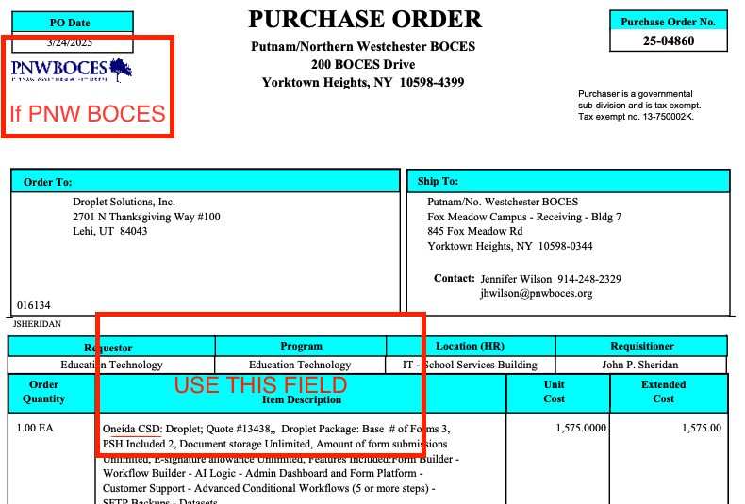

* Any important information on specifics customers of this merchant
  + Special memo’s certain invoices require
  + Invoice changes due to merchant/customer relationship

### Feature Requests *(AE/Implementation/Success to fill)*

### Rewatch Calls *(AE/Implementation/Success to fill)*

* <https://tabs.rewatch.com/video/5ar33w2al5xiw2ul-hold-droplet-tabs-september-24-2024>
* <https://tabs.rewatch.com/video/hve3ajt7986703yn-diego-benjamin-tabs-pricing-discussion-october-16-2024>
* <https://tabs.rewatch.com/video/ovlpkjxsjddwm021-diego-ben-sync-on-proposal-october-30-2024>
* Main demo with Diego and CEO Mike <https://tabs.rewatch.com/video/upij2bfzm8vsy9cr-tabs-demo-november-7-2024>
* Implementation prep call with Diego <https://tabs.rewatch.com/video/yzxsel6jfpq1s3p0-diego-ben-sync-on-implementation-november-14-2024>
* Implementation Kick-off

<https://tabs.rewatch.com/video/x6ijbqgui0o2hddt-tabs-droplet-implementation-kick-off-november-19-2024>